**Multiple linear Regression**

1. computer data set

As we have more than 2 dependent variables and single independent var, I have considered the MLR for this data set, First I have checked for the colinearity problem in the input features ,As there are no such features I have started building my model and I have performed some transformation so that I get a better R^2 square value. I have also mentioned my train_rmse and test_rmse values.

Train_rmse=276.3795

Test_rmse=273.5484

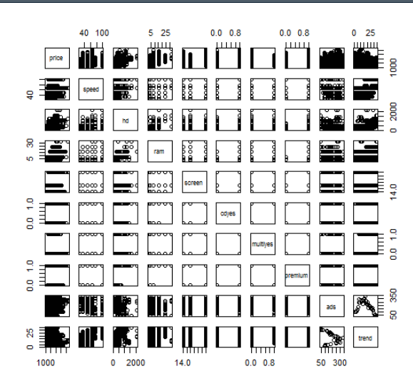

2)

Corolla data set

As we have more than 2 dependent variables and single independent var, I have considered the MLR for this data set, First I have checked for the colinearity problem in the input features ,As there are no such features I have started building my model and I have performed some transformation so that I get a better R^2 square value. I have also mentioned my train_rmse and test_rmse values.

Train_error=1308.712

Test_error=1421.532

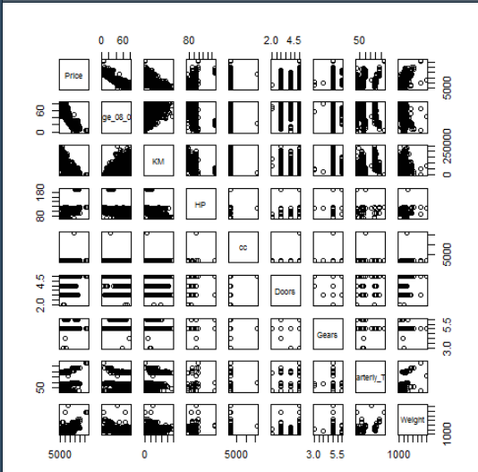

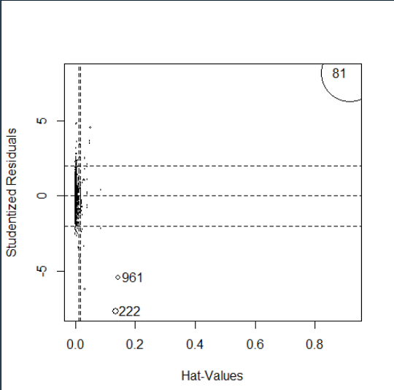

This is the cooks distance plot , here we can see that 81st point is influencer observation and I have removed it and found the p-value insignificant and I have proceeded forward and built my model .